Title: **Oscilloscope** Lab: 23

Course: Electrical Applications Unit: Electrical Lab CLO: 2, 3, 4

Name ____________________________ Grade _______ Date ______________

**Objectives**

1. Student shall calculate alternating current voltage quantities using the characteristics of sinusoidal waveform.
2. Student shall construct an AC series circuit, take voltage readings and analyze the results.

**Assessment**

Students shall demonstrate a comprehension of the objectives listed above by scoring a minimum of 75% on this Lab. Grading shall be based on instructor evaluation.

**Materials**

|  |  |
| --- | --- |
| Student Provided Materials | Department Provided |
| Proto-Board | DC Power Supply |
| Multimeter | AC Generator |
| Resistor Kit | Oscilloscope |
| Speaker |  |
| Calculator |  |

**Theory**

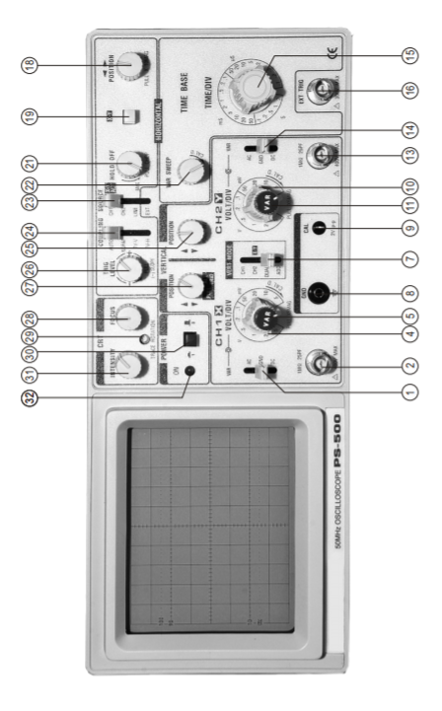

|  |  |
| --- | --- |
| 2 | Vertical input for Channel 1 |
| 4 | Provides step adjustment for vertical sensitivity |
|  |  |
|  |  |
|  |  |
|  |  |
|  |  |
|  |  |

**Graphic**



EP – From x axis to maximum (peak) amplitude.

EPP – From maximum (peak) amplitude to minimum (-peak) amplitude

ERMS – Root, Mean, Square of waveform

|  |  |  |  |  |
| --- | --- | --- | --- | --- |
| $$E_{RMS}=\frac{E_{P}}{\sqrt{2}}$$ | $$E_{P}=\frac{E_{PP}}{2}$$ | $$E_{PP}=E_{P} x 2$$ | $$time=div\left(\frac{time}{div}\right)$$ | $$Hz=\frac{cycles}{time}$$ |

**Instructions**

On Signal Generator, set the following;

* RANGE to x100
* ATTENUATOR to 0dB
* AMPLITUDE to Maximum
* FORM SET to sinewave

On Oscilloscope, set the following;

* VOLTS/DIV to x
* TIME/DIV to x